Web Analytics -- Lab 1 JD comments crawling

Step 1: Analysis the webpage
https://item.jd.com/968093.htm
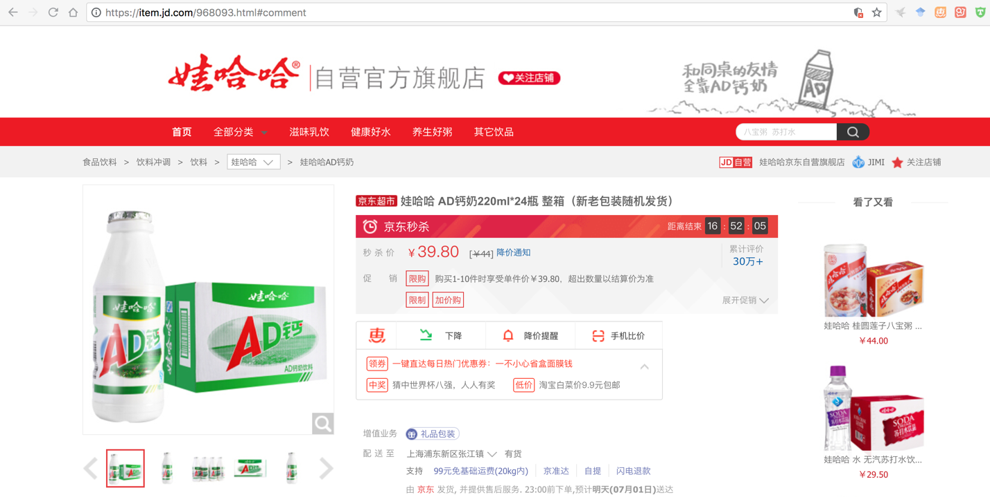
Scroll down to the product comment part, switch the pages, then you will find that the link does not changed. In fact, the comments are loaded asynchronously by using Ajax mechanism. We have to use other tools to capture the data.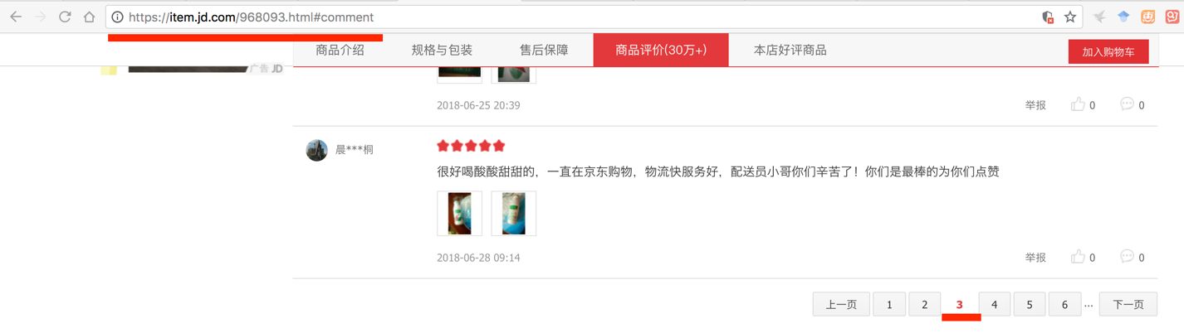
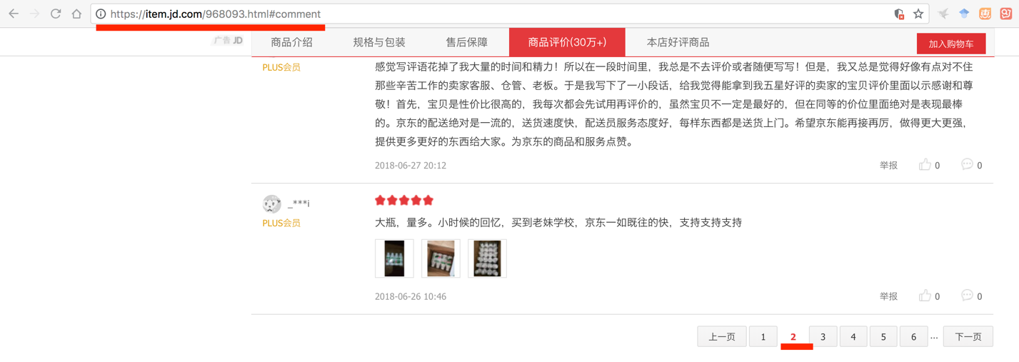

Step 2: Capture the asynchronously loaded comment data
- Click button F12 to the developer model (Chrome browser). Choose some options as below and step 4 clear previous loaded data.
- Switch page to 2, a new JS file will be loaded.
- Copy the Requested URL to the browser and see what is in it.

https://sclub.jd.com/comment/productPageComments.action?callback=fetchJSON_comment98vv107116&productId=968093&score=0&sortType=5&page=1&pageSize=10&isShadowSku=0&rid=0&fold=1
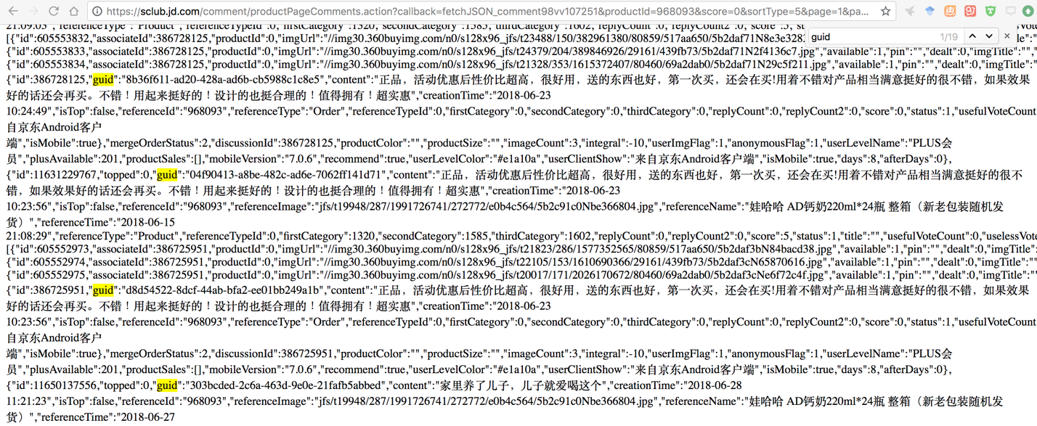
- Switch to other pages, we could learn that the differences in the links are just the page parameters (Red color part).
- Extract the information we need by running following code.
Step 3: Run the code
- Please find the code JD.py attached on the blackboard, and save the file on desktop.
- Run the code and you would see some information in the shell. And we store what we extract into a txt file.

